Calculate Commission

**#1**

For all agents

*From date: 11/01/2018*

*To date: 11/27/2018*

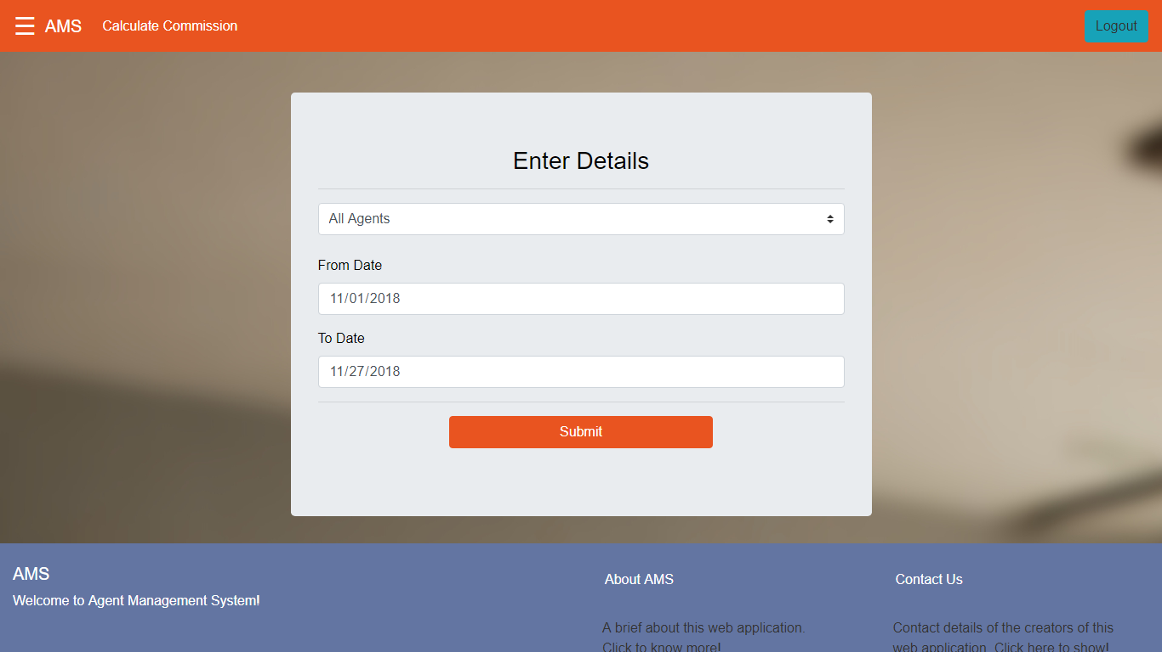

Output:

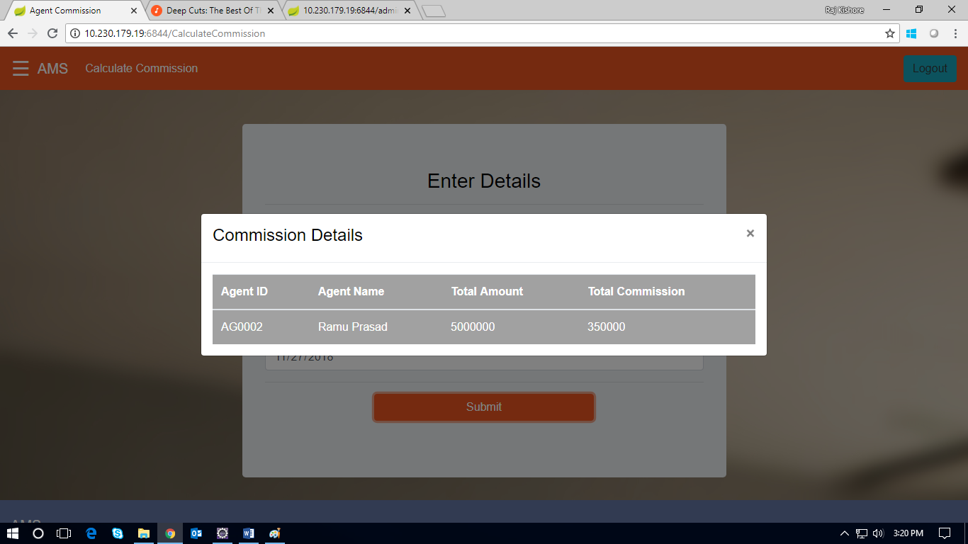

**#2**

For single agent:

*Agent ID: AG0002*

*From Date: 11/01/2018*

*To Date: 11/27/2018*

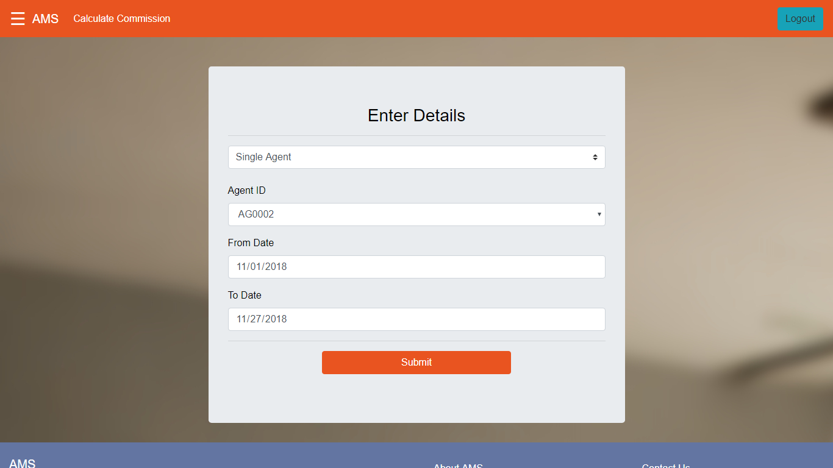

Output:

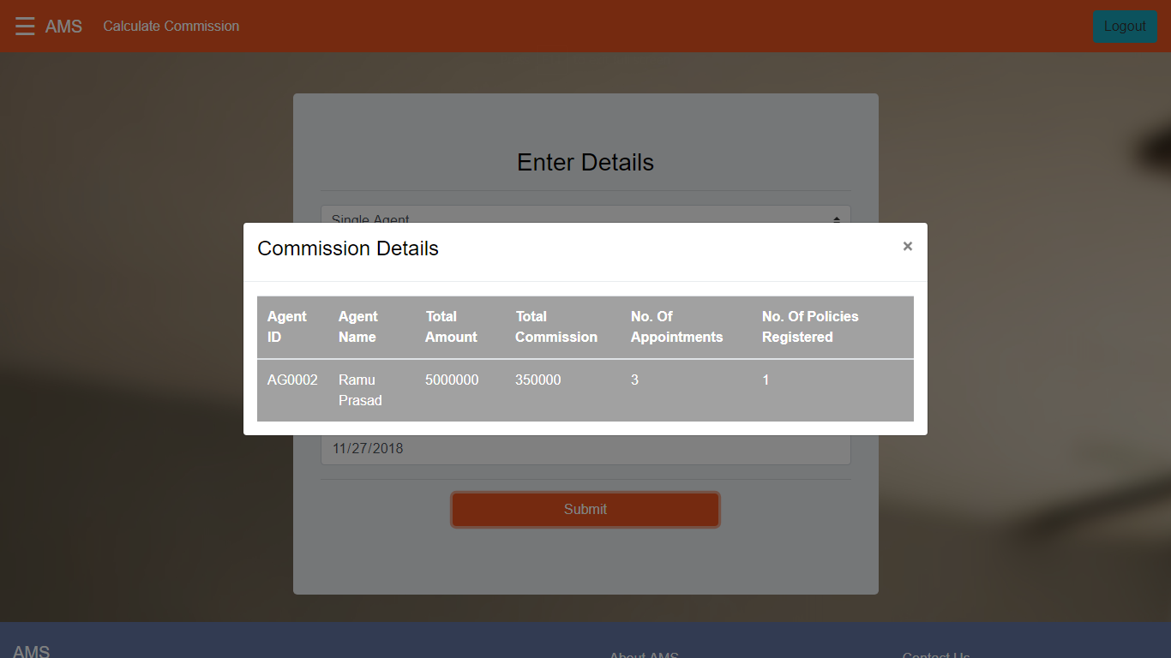

**#3**

For all agents

*From date: 11/19/2018*

*To date: 11/22/2018*

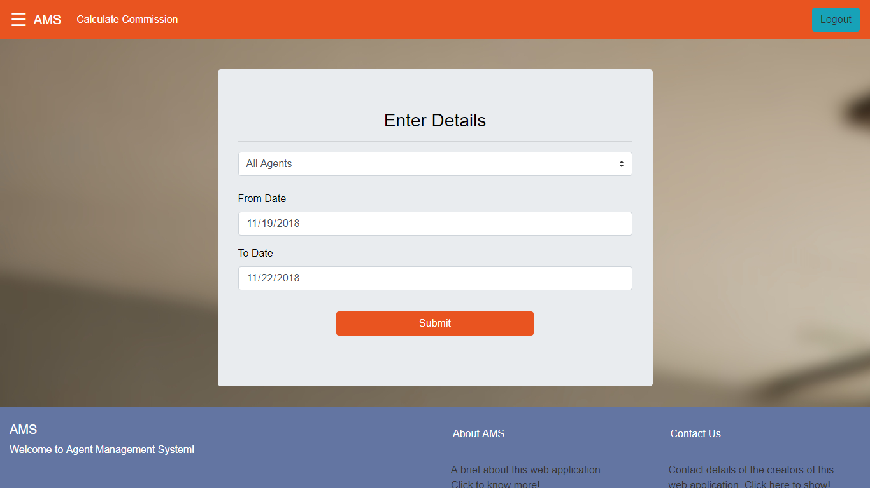

Output:

*Message*

*No corresponding records found! Please select a different date range.*

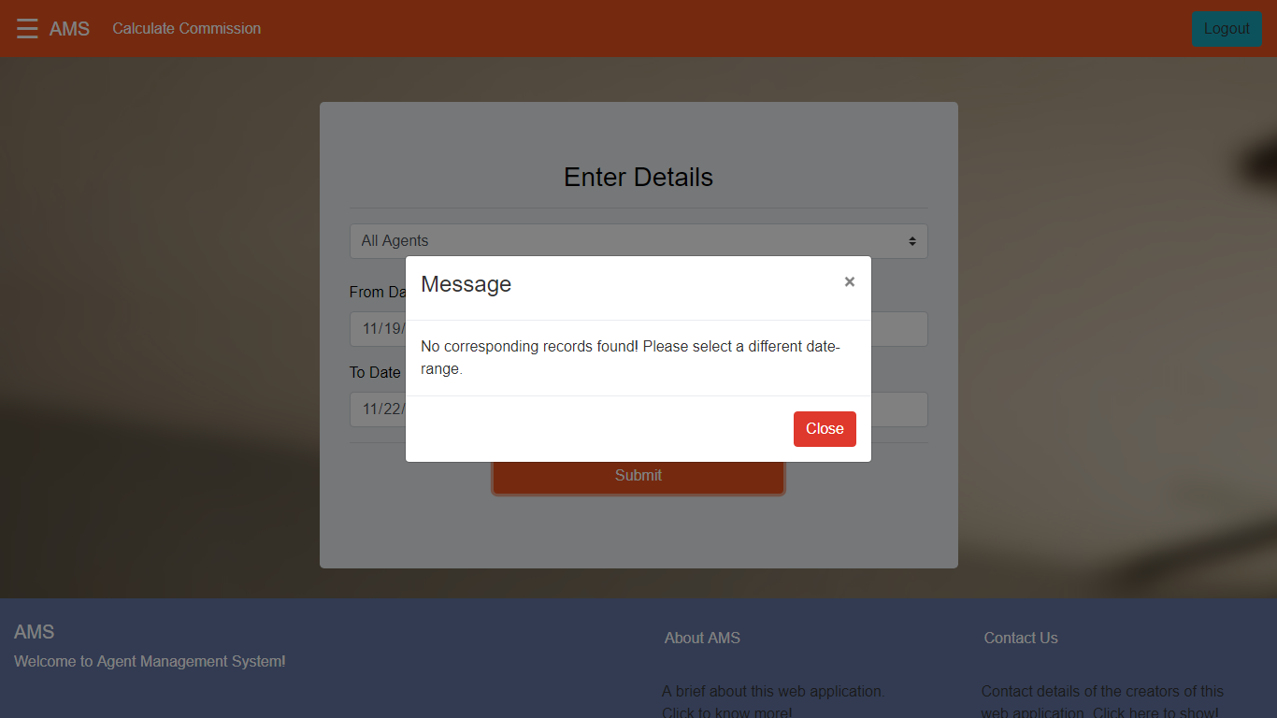

**#4**

For single agent:

*Agent ID: AG0002*

*From Date: 11/01/2018*

*To Date: 11/27/2018*

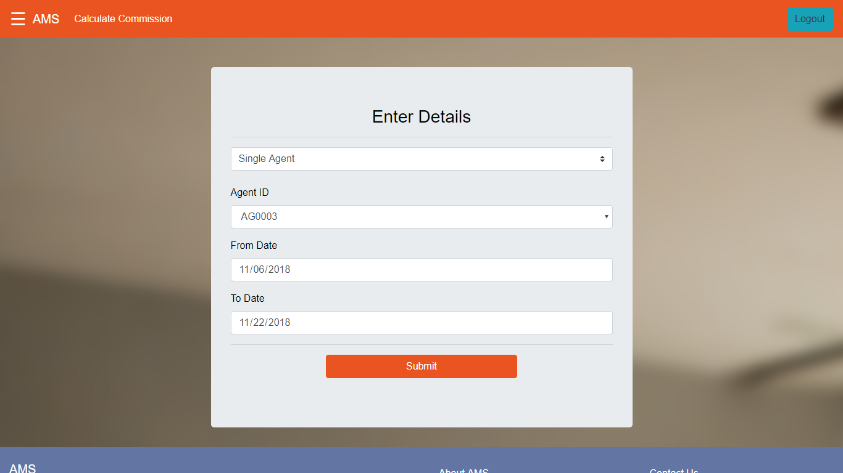

Output:

*Message*

*No corresponding records found! Please select a different date range.*

